A new competition to find the best
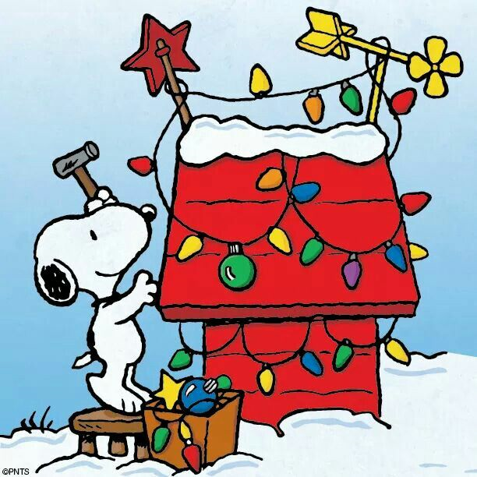 | Christmas Light Displays in the Parish of  Kings Langley* | 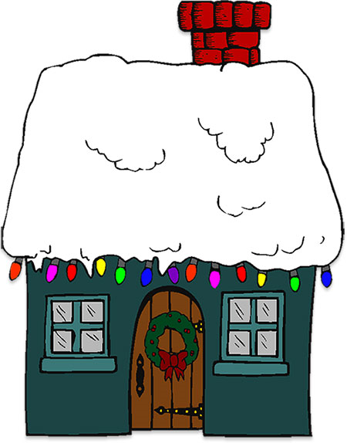

Entry forms are available at www.kingslangley-pc.gov.uk or from our office in Charter Court, Vicarage Lane
First prize £75
Second prize £50
Third prize £25

The closing date for entries is Thursday 17th December
Judging will take place the weekend of 19th & 20th December
The winners to be announced on Tuesday 22nd December

*The Parish of Kings Langley is bounded by the Grand Union Canal to the east, the M25 to the south, Whippendell Bottom to the west and Shendish to the North

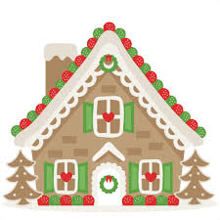 | 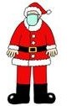 | 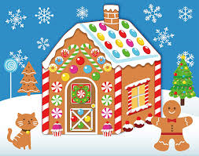

Organised by Kings Langley Parish Council

